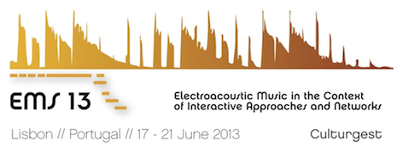

Registration Form

International Conferences
Electroacoustic Music Studies 2013
Electroacoustic Music in the context of interactive approaches and networks

Please fill in this form and send it to 2013ems@gmail.com

Personal Information:

NAME:
SURNAME:

Affiliation (University and/or Research Center):

E-mail contact:
Phone number contact

NIF / Passport Number:

Institutional address:
(for receipt purposes)

Receipt emission |  | You need a receipt |  |  | You don’t need a receipt
Receipt emission |  |  | YES |  |  | NO

FULL REGISTRATION:
 | NOT an EMS Network Member |  | EMS Network Member*
EARLY BOOKING (-10%) | 138€ |  | 108€
GENERAL BOOKING | 150€ |  | 120€
*If you are an EMS Network member, please send us some evidence of it.

STUDENT REGISTRATION SPECIAL PRICE:
 | Student + EMS Network Member registration |  | Student
EARLY BOOKING (-10%) | 84€ |  | 54€
GENERAL BOOKING | 90€ |  | 60€

PORTUGUESE STUDENT REGISTRATION SPECIAL PRICE:
 | Student + EMS Network Member registration |  | Student
EARLY BOOKING (-10%) | 57€ |  | 27€
GENERAL BOOKING | 60€ |  | 30€
Important note:
- You should send us the bank transfer receipt (PDF) of the conference fee payment. Without that document, your registration process will not be considered.
- For student price, a valid student certificate is required (PDF).

SOCIAL PROGRAM (Registration required):

DINNER  19th June at 7:00 pm, Culturgest – 20€ |  | You intend to be present |  |  | You do not intend to be present
DINNER  19th June at 7:00 pm, Culturgest – 20€ |  |  | YES |  |  | NO
Note:
- The fee is to be paid preferably in cash at the registration desk when you receive your EMS13 welcome package.

