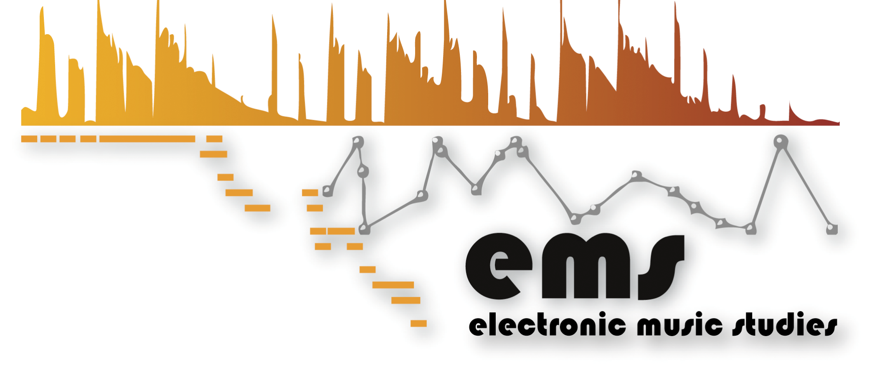

Registration Form
International Conference
Electroacoustic Music Studies 2014
10 - 14 June 2014 | Berlin | Germany

Electroacoustic Music Beyond Concert Performance

Please fill in this form and send it to ems2014.berlin[at]gmail.com

Personal Information:

NAME:
SURNAME:

Affiliation (University and/or Research Center):

E-mail contact:
Phone number contact

NIF / Passport Number:

Institutional address:
(for receipt purposes)

Receipt emission |  | You need a receipt |  |  | You don’t need a receipt
 |  |  | YES |  |  | NO

FULL REGISTRATION:
 | NOT an EMS Network Member |  | EMS Network Member*
EARLY BOOKING (-10%) | 142€ |  | 112€
GENERAL BOOKING | 156€ |  | 125€
*If you are an EMS Network member, please send us some evidence of it.

STUDENT REGISTRATION SPECIAL PRICE:
 | Student + EMS Network Member registration |  | Student
EARLY BOOKING (-10%) | 87€ |  | 56€
GENERAL BOOKING | 94€ |  | 63€

BERLIN STUDENT REGISTRATION SPECIAL PRICE:
 | Student + EMS Network Member registration |  | Student
EARLY BOOKING (-10%) | 59€ |  | 28€
GENERAL BOOKING | 62€ |  | 31€

Important note:
- We can just offer the Paypal payment and no cash payment at the conference. Thus, prices include the 4% Paypal fee.
- You should send us the paypal receipt (PDF) of the conference fee payment. Without that document, your registration process will not be considered.
- For student price, a valid student certificate is required (PDF).

Technical requirements
Formularbeginn

Laser pointer y/n
Formularende
Computer y/n
Sound (CD, audio from your computer) y/n
Video (please specify the connection you are going to use) y/n
Others:

