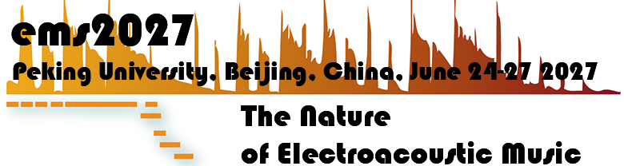

Registration Form
International Conference
Electroacoustic Music Studies 2027
Thursday 24 – Sunday 27 June 2027 |
Peking University, Beijing | CHINA

The Nature of Electroacoustic Music

Please fill in this form and send it to ems27@ems-network.org
(at the latest 10 days prior to the conference for processing the campus access)

Personal Information:

FAMILY NAME:
FIRST/SURNAME:

Affiliation (University and/or Research Center), if any

E-mail contact:
Phone number contact

Passport Number (for Chinese attendees, Chines ID card number)

Institutional address:
(for receipt purposes)

Issuing a receipt |  | You need a receipt |  |  | You don’t need a receipt
Issuing a receipt |  |  | YES |  |  | NO

